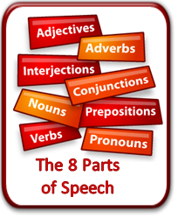
Name:__________________________________Block:_______Date:________

Parts of Speech (POS) Study Guide/Notes
Verbs and Adverbs

- Verb
- Purpose in a sentence: a word that shows ______ or _______ ___ ______
- Action Verb: A verb that _________ the ______ in the sentence.
  - examples: swim, jump, drop, whistle, run, sing, plan
  - example: I ran all the way home.
- Linking Verb: A verb that expresses a _______ ____ _______.
  - examples: loves, believes, seem, looks, tastes,
  - example: The cake tastes delicious.
- Helping Verb: A verb that _____ the _____ verb express ______ meaning.
- examples: has planted, will build, should take, did question
- example: The farmer has planted the crops.
- Highlight the verbs in the following sentences:
- Billy cried all night. ______
- She will sing like an angel on stage. _______ ___ ____
- I jolted in my chair when the doorbell rang. ______
- Harry smells bad. _______
- I feel energetic. _______
- John swam the 200 meter freestyle. _______
- Adverb
- Purpose in a sentence: to ______ (help out) _____, ___________, or other _______ by explaining____, _____, _____, ______, ______ _____, and _____ _____.
- Sometimes (but not always) end in –ly
- Highlight the adverbs in the following sentences:
- Sam looked sadly into the sky.
- He wailed endlessly about his lost rock, but the dark night quietly ignored him.
- The lifeguard swam extremely fast.
- Cathy always shops with her friends.
- Our space probe landed softly on the moon today.

